Guide

PLP Fields
(10h)
Use reusable solution from: https://csnetsuite.custhelp.com/app/answers/answer_view/a_id/1007125/loc/en_US
Copy the code and adapt it.
Use data-view: ItemDetails.Options
This reusable solution, takes the data-view and adds a view and inside of it it pastes the custom fields specified via configuration json, to the view attached.
To get the objects specified on configuration json filled up by data, the solution accesses the item on plp component and with context data item, it compares its content with the objects on configuration json and if the ids matches, it fills up the contents of the configuration json object created and then pastes it later on the view.

PLP Inventory Display
(20h)
Add to the previous reusable solution, and since we get item we can get inventory display info from there and extend and show it.
Agregarle a esto, en el template que le paso el item, desmembarlo y mostrar locación. Para esto necesito tener activado inventory display que creo que no está activado.

PLP add to cart with quantity
(40h)
Client does not want it horizontal.
Reusable solution:
https://csnetsuite.custhelp.com/app/answers/answer_view/a_id/1007124/loc/en_US
It limit its to the 4th view option, the other 3 do not have it.
Also I think the client wants for all of them, and reusable solution use facets I do not know if I need to use that.

For the new solution:
- Use data-view: addToCart.
- Hide the existing QuickAddToCart data view that contains the button.
- Extend custom fields plp reusable solution, and pass to the new plp view the Cart component.
- Add on the view add to cart button and quantity button to template as well as custom fields.
- Associate add to cart button with addLines function passing quantities.
- Call addLines function, pass there quantity field, and internal id of the item field which comes from context data
- Add layout.showConfirmation button.
Assumptions:
- Matrix items not needed
Some questions:
- How do we consider out of stock behavior?
- May it have some limitations I am not seeing?
- What if items do not have prices or are not well configured?

Annotations:
Pass the value of the internalid of item and quantity field when the button is clicked. As long as it is not a matrix item. Add the out of stock behaviour.
And make sure that items are configured properly. I see other items doesn’t have prices.

Some questions
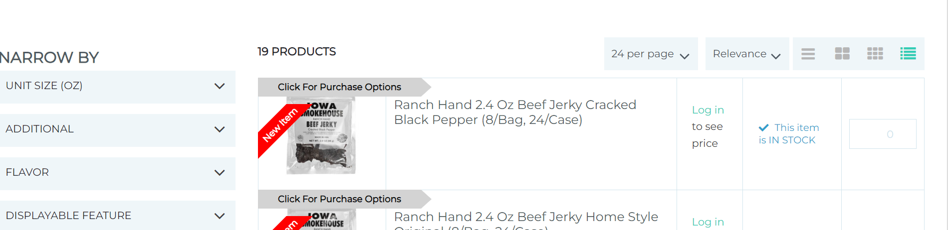
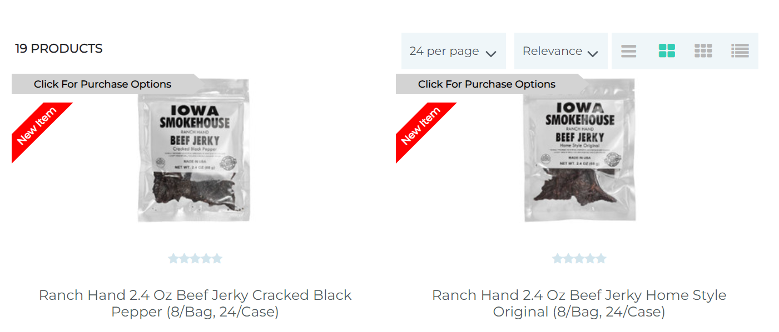
May it be a problem with the type of view?

Wishlist button
(10h)
Add a button on header, with data-view: StoreLocatorHeaderLink.
If you are logged in, it should redirect you to my wishlist. If not, it will send you to sign up page.

- How can I get behavior of wishlist button, so if you are not logged in it redirects you to sign up, and if you are logged in it redirects you to wishlist?

Buttons on Account Overview:
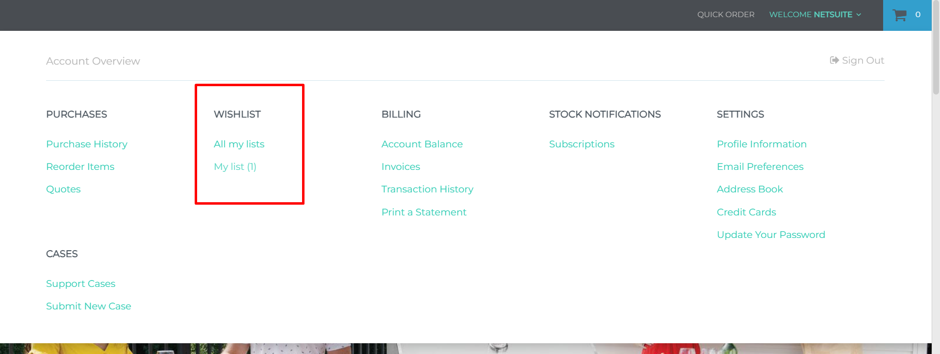
All my lists button:
<a class="header-menu-myaccount-anchor-level3" tabindex="-1" href="https://dev.mybroadline.com/scs/my_account.ssp?fragment=/wishlist" data-touchpoint="customercenter" data-hashtag="#/wishlist" name="All my lists">All my lists</a>
My list button:
- If you do not have a wishlist created:
<a class="header-menu-myaccount-anchor-level3" tabindex="-1" href="#" data-touchpoint="customercenter" data-hashtag="#/wishlist/tmpl_1" name="My list (0)">My list (0)</a>
- If you have a wishlist created:
<a class="header-menu-myaccount-anchor-level3" tabindex="-1" href="https://dev.mybroadline.com/scs/my_account.ssp?fragment=/wishlist/4" data-touchpoint="customercenter" data-hashtag="#/wishlist/4" name="My list (1)">My list (1)</a>
I can’t open my account, throws a locale error: SC.ENVIRONMENT.currentLanguage.locale+".js?t=1685991697626"
Add to wishlist button without being logged in:
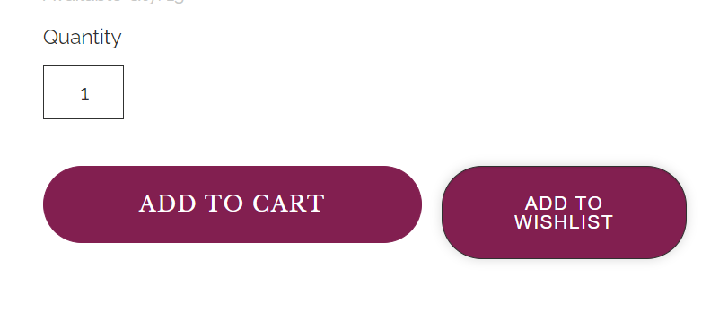
<button class="product-list-control-button-wishlist" data-action="show-productlist-control" data-toggle="showFlyout" type="button"> Add to Wishlist </button>

New requirement
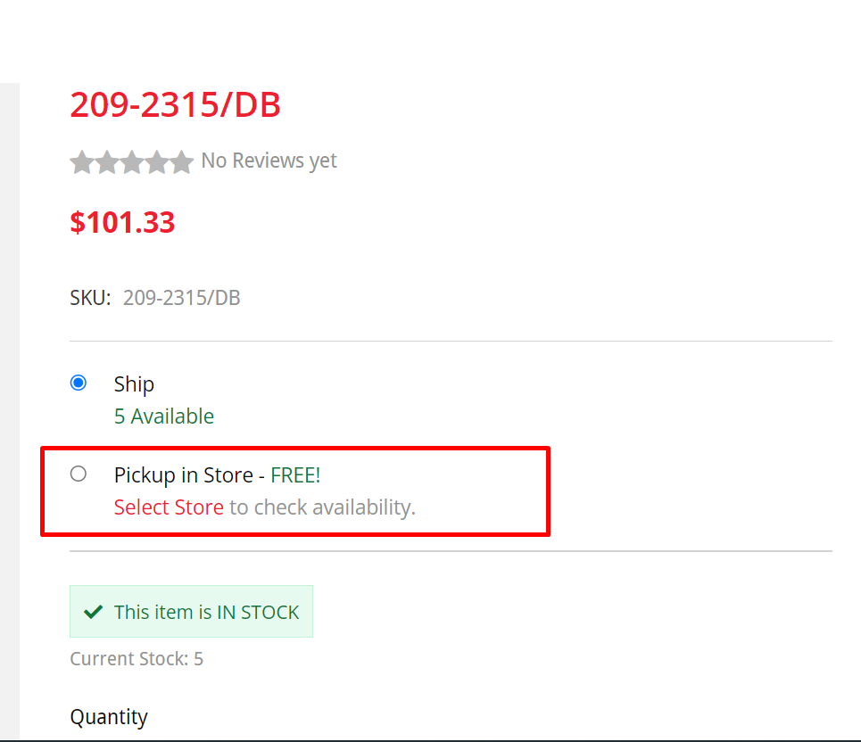
They have 2 pick up in store locations, charlotte and Greenville.
Customer wants to be able to have these 2 stores as radio buttons bellow ship, instead of having to click on pick up in store and having to open the pop up to select:
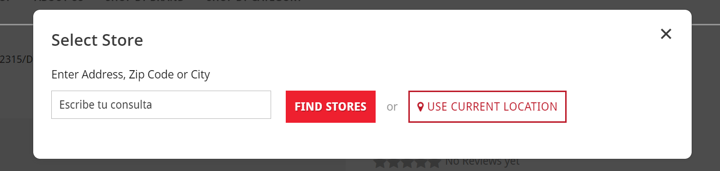

September 2023

- Add charlotte + pressley (6h)
- Add quantity +- field (20h a 40h)
- Anonymous user disable PLP location (10h)
- MSRP vs dealer price:

MSRP es el pricelevel de NetSuite.
Dealer Price es el que te asigna NetSuite en Customer Record -> Financial tab -> Item Pricing tab en la tabla, pones edit y agregas un item y pones un custom Price level
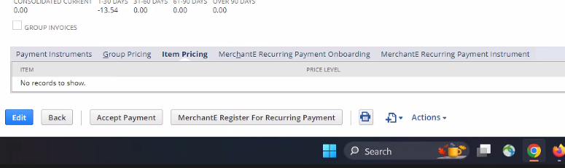
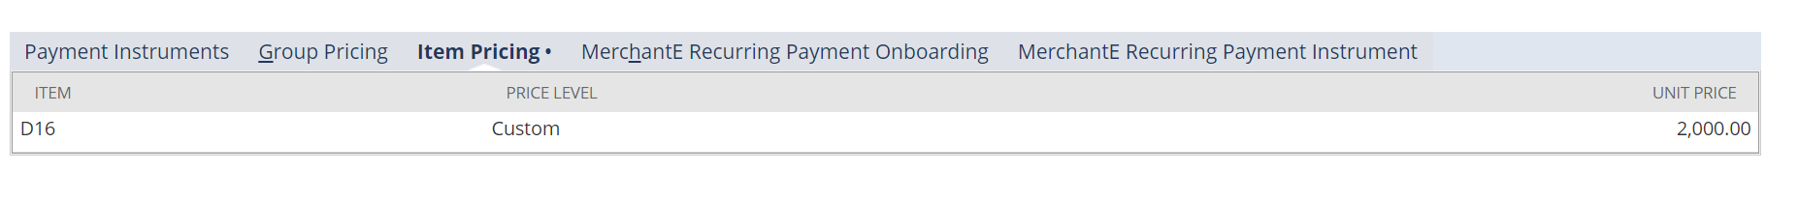
Si no estas logueado, te muestra siempre el Pricelevel de NetSuite, es decir el MSRP.
Cuando estas logueado, te muestra el dealer Price.

Si estoy logueado -> mostrar 2 prices:
- Pricelevel o MSRP con etiqueta MSRP al lado
- Dealer Price (ya se muestra) con etiqueta al lado “dealer Price”
Si no estoy logueado -> mostrar 1 solo Price:
- Pricelevel o MSRP (ya viene con netsuite) y una etiqueta que diga MSRP

Solution:
Context data -> always comes base price, but MSRP and custom price set do not come
Add fieldsets to website record, these are different pricelevels, for example pricelevel_5

Offer to the client to use native strikethrough pricing, which can be configured with 2 prices.
Check on strikethrough pricing customization on help, is the same data that you need.

